Q. Write a program in python to demonstrate Bisection method.

Aim: To write a program in python to demonstrate Bisection method.

Program:
def f(x):
return x**3 - 4*x - 9
a = float(input("Enter a: "))
b = float(input("Enter b: "))
tolerance = float(input("Enter tolerance (e.g., 0.0001): "))
if f(a) * f(b) > 0:
print("No root found in this interval. Try different values of a and b.")
else:
print("\nIteration\t a\t\t b\t\t xr\t\t f(a)\t\t f(b)\t\t f(xr)")
iteration = 1
while True:
xr = (a + b) / 2
fa = f(a)
fb = f(b)
fxr = f(xr)
print(f"{iteration:>5}\t {a:.6f}\t {b:.6f}\t {xr:.6f}\t {fa:.6f}\t {fb:.6f}\t {fxr:.6f}")
if abs(fxr) < tolerance:
print("\nApproximate root:", xr)
break
if fa * fxr < 0:
b = xr
else:
a = xr
iteration += 1

Output:
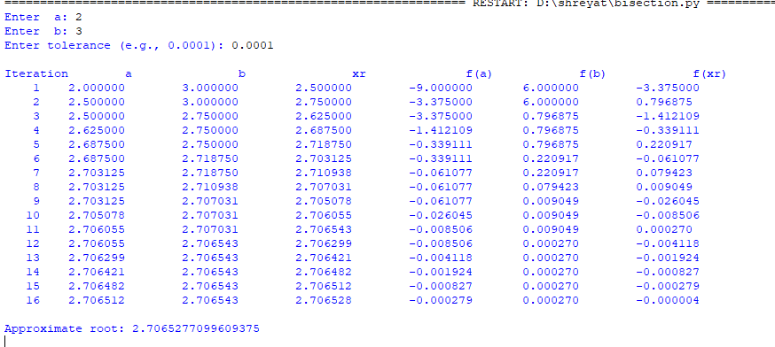

Conclusion: The above program has been executed successfully.

Q. Write a program in python to demonstrate Regula falsi method.

Aim: To write a program in python to demonstrate Regula falsi method.

Program:
def f(x):

return x**3 - x - 2
a = float(input("Enter a: "))
b = float(input("Enter b: "))
if f(a) * f(b) > 0:
print("No root found in this interval. Try different values of a and b.")
else:
print("\nIteration\t a\t\t b\t\t xr\t\t f(a)\t\t f(b)\t\t f(xr)")
xr_old = 0
iteration = 1
while True:

fa = f(a)
fb = f(b)
xr = (a*fb-b*fa)/(fb-fa)
fxr = f(xr)
print(f"{iteration:>5}\t {a:.6f}\t {b:.6f}\t {xr:.6f}\t {fa:.6f}\t {fb:.6f}\t {fxr:.6f}")
if abs(xr-xr_old) < 0.0001 or abs(fxr)<0.0001:
print("\nApproximate root:", xr)
break
if fa * fxr < 0:
b = xr
else:
a = xr
xr_old = xr
iteration += 1

Output:
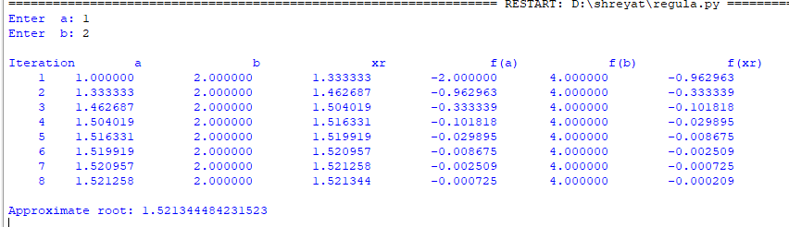

Conclusion: The above program has been executed successfully.

Q. Write a program in python to demonstrate Newton raphson method.

Aim: To write a program in python to demonstrate Newton Raphson method.

Program:
def f(x):
return x**3 - x - 2

def df(x):
return 3*x**2 - 1
x0 = 1.5
e = 0.0001
step = 1
print("------------------------------------------------------------")
print(" NEWTON–RAPHSON METHOD")
print("------------------------------------------------------------")
print(" Step\t x0\t\t f(x0)\t f'(x0)\t x1")
print("------------------------------------------------------------")
while True:
f0 = f(x0)
df0 = df(x0)
x1 = x0 - (f0 / df0)
print(f" {step:<5d}\t {x0:<10.6f}\t {f0:<10.6f}\t {df0:<10.6f}\t {x1:<10.6f}")
if abs(x1 - x0) < e:
break
x0 = x1
step += 1
print("------------------------------------------------------------")
print(f" Root of the equation is approximately : {x1:.6f}")
print(f" Rounded to 4 decimal places : {round(x1,4)}")
print("------------------------------------------------------------")

Output:
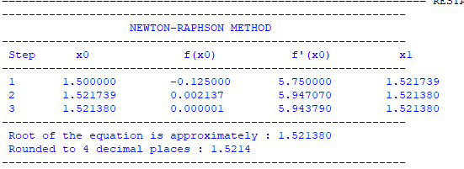

Conclusion: The above program has been executed successfully.

Q. Write a program in python to demonstrate Newton Forward Interpolation.

Aim: To write a program in python to demonstrate Newton Forward Difference Interpolation.

Program:
from math import factorial
def forward_difference(y):
n = len(y)
diff_table = [y]
for i in range(1, n):
col = []
for j in range(n - i):
col.append(diff_table[i - 1][j + 1] - diff_table[i - 1][j])
diff_table.append(col)
return diff_table
def newton_forward(x, y, value):
n = len(x)
h = x[1] - x[0] # step size (assumes equally spaced x values)
p = (value - x[0]) / h
diff_table = forward_difference(y)
result = y[0]
term = 1
for i in range(1, n):
term *= (p - (i - 1))
result += (term * diff_table[i][0]) / factorial(i)

return result, diff_table
n = int(input("Enter number of data points: "))
x = []
y = []
print("Enter x values (equally spaced):")
for i in range(n):
x.append(float(input(f"x[{i}] = ")))
print("Enter y values (corresponding to f(x), type 'null' if unknown):")
for i in range(n):
val = input(f"y[{i}] = ")
if val.lower() == "null":
y.append(None) # store as None
else:
y.append(float(val))
x_clean = []
y_clean = []
for xi, yi in zip(x, y):
if yi is not None:
x_clean.append(xi)
y_clean.append(yi)
if len(x_clean) < 2:
print("\nError: Not enough known y values for interpolation.")
else:
x_val = float(input("Enter the value of x to interpolate: "))
result, table = newton_forward(x_clean, y_clean, x_val)
print("\nForward Difference Table:")
for i in range(len(table)):
print(f"Δ^{i}y:", table[i])
print(f"\nInterpolated value at x = {x_val} is {result}")

Output:
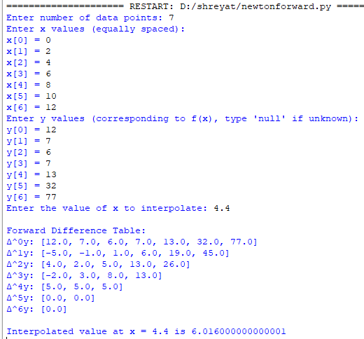

Conclusion: The above program has been executed successfully.

Q. Write a program in python to demonstrate Newton Backward Interpolation.

Aim: To write a program in python to demonstrate Newton Backward Difference Interpolation.

Program:
from math import factorial
def backward_difference_table(y):
n = len(y)
table = [[0 for _ in range(n)] for _ in range(n)]
for i in range(n):
table[i][0] = y[i]
for j in range(1, n):
for i in range(n-1, j-1, -1):
table[i][j] = table[i][j-1] - table[i-1][j-1]
return table
def newton_backward(x, y, xp):
n = len(x)
h = x[1] - x[0]
p = (xp - x[-1]) / h
table = backward_difference_table(y)
yp = y[-1]
term = 1
for i in range(1, n):
term *= (p + i - 1)
yp += (term * table[n-1][i]) / factorial(i)

return yp, table

n = int(input("Enter number of data points: "))
x = []
y = []
print("Enter x values (equally spaced):")
for i in range(n):
x.append(float(input(f"x[{i}] = ")))
print("Enter y values:")
for i in range(n):
y.append(float(input(f"y[{i}] = ")))
xp = float(input("Enter x value to interpolate: "))
result, table = newton_backward(x, y, xp)
print("\nBackward Difference Table:")
for i in range(n):
for j in range(i + 1):
print(table[i][j], end=" ")
print()
print(f"\nInterpolated value at x = {xp} is {result}")

Output:
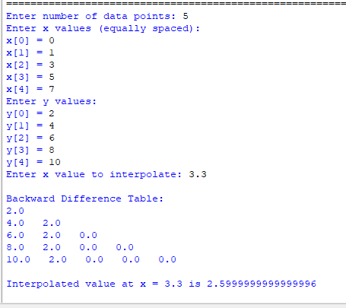

Conclusion: The above program has been executed successfully.

Q. Write a program in python to demonstrate to generate and display the forward difference table using Infinite Forward Method.

Aim: To write a program in python to demonstrate to generate and display the forward difference table using Infinite Forward Method.

Program:
def forward_difference_table(x, y):
n = len(y)
diff_table = [y.copy()]
for i in range(1, n):
row = []
for j in range(n - i):
value = diff_table[i - 1][j + 1] - diff_table[i - 1][j]
row.append(value)
diff_table.append(row)
return diff_table
def display_table(x, diff_table):
n = len(x)
print("\nForward Difference Table:")
print("x\t" + "\t".join([f"Δ^{i}y" for i in range(n)]))
for i in range(n):
row = [f"{x[i]:.2f}"]
for j in range(n - i): row.append(f"{diff_table[j][i]:.2f}")
print("\t".join(row))
def main():
# User input
n = int(input("Enter the number of data points: "))
print("Enter x values (equally spaced):")
x = [float(input(f"x[{i}]: ")) for i in range(n)]
print("Enter corresponding y values:")
y = [float(input(f"y[{i}]: ")) for i in range(n)]
h = x[1] - x[0]
if not all(abs(x[i + 1] - x[i] - h) < 1e-5 for i in range(n - 1)):
print("Error: x values are not equally spaced.")
return
diff_table = forward_difference_table(x, y)
display_table(x, diff_table)
if __name__ == "__main__":
main()

Output:
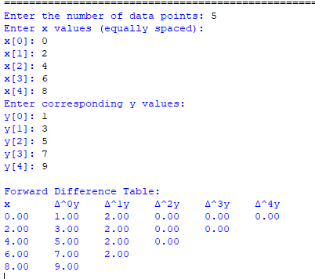

Conclusion: The above program has been executed successfully.

Q. Write a program in python to demonstrate to find missing term.

Aim: To write a program in python to demonstrate to find missing term.

Program:
def solve_five_point(y):
coeffs = [1, -4, 6, -4, 1]
if y.count(None) != 1:
print("Error: Exactly one value must be 'null'.")
return None
missing_index = y.index(None)
total = 0
for i in range(5):
if i != missing_index:
total += coeffs[i] * y[i]
y_missing = -total / coeffs[missing_index]
return missing_index, y_missing
def check_equal_spacing(x):
h = x[1] - x[0]
for i in range(1, len(x) - 1):
if abs((x[i + 1] - x[i]) - h) > 1e-6:
return False
return True
def main():
print("Enter x values (must be equally spaced):")
x = []
for i in range(5):
try:
x_val = float(input(f"x[{i}]: "))
x.append(x_val)
except ValueError:
print("Invalid x value.")
return
if not check_equal_spacing(x):
print("Error: x values are not equally spaced.")
return
print("Enter y values (use 'null' for missing value):")
y = []
for i in range(5):
val = input(f"y[{i}]: ")
if val.lower() == "null":
y.append(None)
else:
try:
y.append(float(val))
except ValueError:
print("Invalid y value.")
return
result = solve_five_point(y)
if result:
idx, missing_y = result
print(f"\nMissing value y[{idx}] = {missing_y:.4f}")
if __name__ == "__main__":
main()

Output:
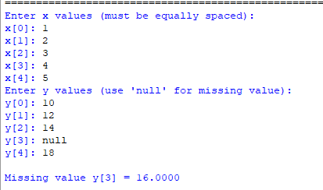

Conclusion: The above program has been executed successfully.

Q. Write a program in python to demonstrate Curve fitting.

Aim: To write a program in python to demonstrate Curve fitting.

Program:
print("------------------------------------------------------------")
print(" CURVE FITTING – STRAIGHT LINE")
print("------------------------------------------------------------")
x = [1, 2, 3, 4, 5]
y = [2, 4, 5, 4, 5]
n = len(x)
sum_x = sum(x)
sum_y = sum(y)
sum_x2 = sum(i*i for i in x)
sum_xy = sum(x[i]*y[i] for i in range(n))
a = ((sum_y * sum_x2) - (sum_x * sum_xy)) / (n * sum_x2 - sum_x**2)
b = ((n * sum_xy) - (sum_x * sum_y)) / (n * sum_x2 - sum_x**2)
print(" x\t y\t x²\t xy")
print("------------------------------------------------------------")
for i in range(n):
print(f" {x[i]}\t {y[i]}\t {x[i]**2}\t {x[i]*y[i]}")
print("------------------------------------------------------------")
print(f" Σx = {sum_x}, Σy = {sum_y}, Σx² = {sum_x2}, Σxy = {sum_xy}")
print("------------------------------------------------------------")
print(f" Equation of best fit line: y = {a:.4f} + {b:.4f}x")
print("------------------------------------------------------------")

Output:
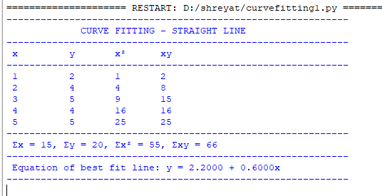

Conclusion: The above program has been executed successfully.

Q. Write a program in python to demonstrate Curve fitting.

Aim: To write a program in python to demonstrate Curve fitting.

Program:
print("------------------------------------------------------------")
print(" CURVE FITTING – STRAIGHT LINE")
print("------------------------------------------------------------")
x = [1, 2, 3, 4, 5]
y = [2, 4, 5, 4, 5]
n = len(x)
sum_x = sum(x)
sum_y = sum(y)
sum_x2 = sum(i*i for i in x)
sum_xy = sum(x[i]*y[i] for i in range(n))
a = ((sum_y * sum_x2) - (sum_x * sum_xy)) / (n * sum_x2 - sum_x**2)
b = ((n * sum_xy) - (sum_x * sum_y)) / (n * sum_x2 - sum_x**2)
print(" x\t y\t x²\t xy")
print("------------------------------------------------------------")
for i in range(n):
print(f" {x[i]}\t {y[i]}\t {x[i]**2}\t {x[i]*y[i]}")
print("------------------------------------------------------------")
print(f" Σx = {sum_x}, Σy = {sum_y}, Σx² = {sum_x2}, Σxy = {sum_xy}")
print("------------------------------------------------------------")
print(f" Equation of best fit line: y = {a:.4f} + {b:.4f}x")
print("------------------------------------------------------------")

Output:

Conclusion: The above program has been executed successfully.

Q. Write a program in python to demonstrate Gaussian Elimination Method.

Aim: To write a program in python to demonstrate Gaussian Elimination Method.

Program:
n = int(input("Enter number of equations: "))
a = []
for i in range(n):
row = list(map(float, input(f"Enter coefficients of equation {i+1} (including RHS): ").split()))
a.append(row)
def print_matrix(mat):
for r in mat:
print("\t".join(f"{val:8.3f}" for val in r))
print()
print("\nInitial Augmented Matrix:")
print_matrix(a)
for i in range(n):
if a[i][i] == 0:
print("Mathematical Error! Pivot element is zero.")
exit()
for j in range(i+1, n):
ratio = a[j][i] / a[i][i]
for k in range(n+1):
a[j][k] -= ratio * a[i][k]
print(f"After eliminating column {i+1}:")
print_matrix(a)
x = [0 for _ in range(n)]
for i in range(n-1, -1, -1):
x[i] = a[i][n]
for j in range(i+1, n):
x[i] -= a[i][j] * x[j]
x[i] /= a[i][i]
print("Final Upper Triangular Matrix:")
print_matrix(a)
print("Solution:")
for i in range(n):
print(f"x{i+1} = {x[i]:.4f}")

Output:
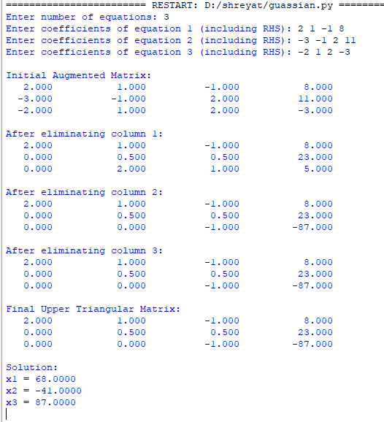
Conclusion: The above program has been executed successfully.

Q. Write a program in python to demonstrate Taylor Series.

Aim: To write a program in python to demonstrate Taylor Series.

Program:
import math
def f(x, y):
return -y
x0 = 0
y0 = 1
h = 0.1
order = 5
derivs = [0]*order
derivs[0] = f(x0, y0)
for i in range(1, order):
derivs[i] = (-1)**i * y0
y1 = y0
for i in range(order):
y1 += (derivs[i] * (h**(i+1))) / math.factorial(i+1)
print("----------------------------------------------------")
print("Derivatives at x0 = %.1f, y0 = %.1f:" % (x0, y0))
print("----------------------------------------------------")
for i in range(order):
print(f"y^({i})(0) = {derivs[i]:.6f}")
print("\n----------------------------------------------------")
print(f"Taylor approximation up to order {order}:")
print(f"y({x0+h}) ≈ {y1:.10f}")
print(f"Rounded to 4 decimal places: {round(y1,4)}")
print("----------------------------------------------------")

Output:
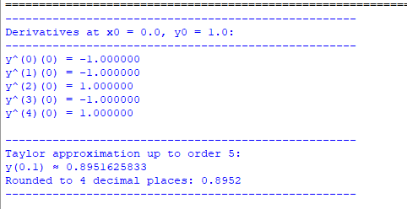
Conclusion: The above program has been executed successfully.

Q. Write a program in python to demonstrate Euler’s method.

Aim: To write a program in python to demonstrate Euler’s method.

Program:
def f(x, y):
return x + y
x0 = 0
y0 = 1
h = 0.1
xn = 0.5
print("------------------------------------------------------------")
print(" EULER'S METHOD")
print("------------------------------------------------------------")
print(" x0\t\t y0\t\t f(x,y)\t y_new")
print("------------------------------------------------------------")
while x0 < xn:
fxy = f(x0, y0)
y1 = y0 + h * fxy
print(f" {x0:<8.2f}\t {y0:<10.6f}\t {fxy:<10.6f}\t {y1:<10.6f}")
x0 += h
y0 = y1
print("------------------------------------------------------------")
print(f" Approximate value of y at x = {xn} is {y0:.6f}")
print(f" Rounded to 4 decimal places : {round(y0,4)}")
print("------------------------------------------------------------")

Output :
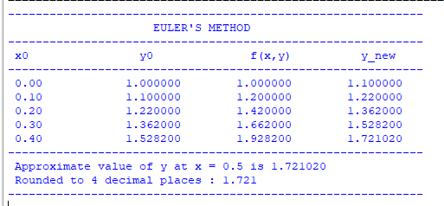

Conclusion: The above program has been executed successfully.

Q. Write a program in python to demonstrate Modified Euler’s method.

Aim: To write a program in python to demonstrate Modified Euler’s method.

Program:
def f(x, y):
return x + y
x0 = 0
y0 = 1
h = 0.1
xn = 0.5
print("------------------------------------------------------------")
print(" MODIFIED EULER (HEUN'S) METHOD")
print("------------------------------------------------------------")
print(" x0\t\t y0\t\t Pred\t\t Corr\t\t y")
print("------------------------------------------------------------")
while x0 < xn:
y_pred = y0 + h * f(x0, y0)
y_corr = y0 + (h / 2) * (f(x0, y0) + f(x0 + h, y_pred))
print(f" {x0:<8.2f}\t {y0:<10.6f}\t {y_pred:<10.6f}\t {y_corr:<10.6f}\t {y_corr:<10.6f}")
y0 = y_corr
x0 += h
print("------------------------------------------------------------")
print(f" Approximate value of y at x = {xn} is {y0:.6f}")
print(f" Rounded to 4 decimal places : {round(y0,4)}")
print("------------------------------------------------------------")

Output :
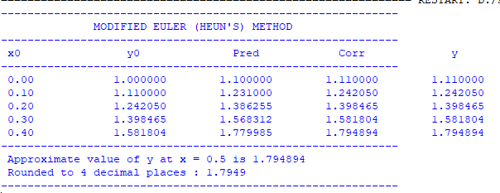

Conclusion: The above program has been executed successfully.

Q. Write a program in python to demonstrate Runge-Kutta 2nd order method.

Aim: To write a program in python to demonstrate Runge-Kutta 2nd order method.

Program:
def f(x, y):
return x + y
x0 = 0
y0 = 1
h = 0.1
xn = 0.5
print("------------------------------------------------------------")
print(" RUNGE-KUTTA 2nd ORDER METHOD")
print("------------------------------------------------------------")
print(" x\t\t y\t\t k1\t\t k2\t\t y_new")
print("------------------------------------------------------------")
while x0 < xn:
k1 = f(x0, y0)
k2 = f(x0 + h, y0 + h * k1)
y1 = y0 + (h / 2) * (k1 + k2)
print(f" {x0:<8.2f}\t {y0:<10.6f}\t {k1:<10.6f}\t {k2:<10.6f}\t {y1:<10.6f}")
x0 += h
y0 = y1
print("------------------------------------------------------------")
print(f" Approximate value of y at x = {xn} is {y0:.6f}")
print(f" Rounded to 4 decimal places : {round(y0,4)}")
print("------------------------------------------------------------")

Output:
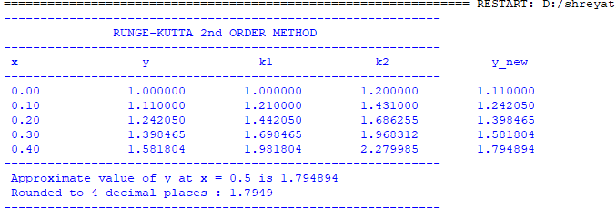

Conclusion: The above program has been executed successfully.

Q. Write a program in python to demonstrate Runge-Kutta 4th order method.

Aim: To write a program in python to demonstrate Runge-Kutta 4th order method.

Program:
def f(x, y):
return x + y
x0 = 0
y0 = 1
h = 0.1
xn = 0.5
print("------------------------------------------------------------")
print(" RUNGE-KUTTA 4th ORDER METHOD")
print("------------------------------------------------------------")
print(" x\t\t y\t\t k1\t\t k2\t\t k3\t\t k4\t\t y_new")
print("------------------------------------------------------------")
while x0 < xn:
k1 = f(x0, y0)
k2 = f(x0 + h / 2, y0 + (h / 2) * k1)
k3 = f(x0 + h / 2, y0 + (h / 2) * k2)
k4 = f(x0 + h, y0 + h * k3)
y1 = y0 + (h / 6) * (k1 + 2 * k2 + 2 * k3 + k4)
print(f" {x0:<8.2f}\t {y0:<10.6f}\t {k1:<10.6f}\t {k2:<10.6f}\t {k3:<10.6f}\t {k4:<10.6f}\t {y1:<10.6f}")
x0 += h
y0 = y1
print("------------------------------------------------------------")
print(f" Approximate value of y at x = {xn} is {y0:.6f}")
print(f" Rounded to 4 decimal places : {round(y0,4)}")
print("------------------------------------------------------------")

Output:
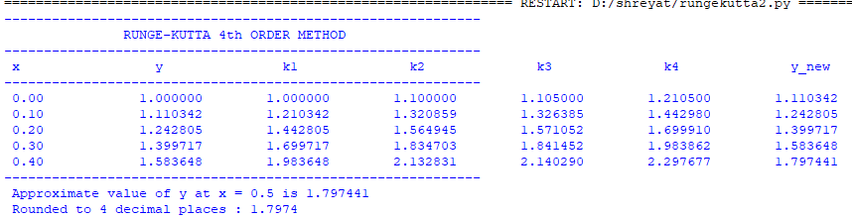

Conclusion: The above program has been executed successfully.

Q. Write a program in python to demonstrate Trapezoidal rule.

Aim: To write a program in python to demonstrate Trapezoidal rule.

Program:
def f(x):
return x**2 + 1
a = 0
b = 1
n = 6
h = (b - a) / n
sum_val = f(a) + f(b)
print("------------------------------------------------------------")
print(" TRAPEZOIDAL RULE")
print("------------------------------------------------------------")
print(" i\t x\t\t f(x)")
print("------------------------------------------------------------")
for i in range(1, n):
x = a + i * h
fx = f(x)
print(f" {i:<2}\t {x:<10.6f}\t {fx:<10.6f}")
sum_val += 2 * fx
I = (h / 2) * sum_val
print("------------------------------------------------------------")
print(f" Approximate value of integral = {I:.6f}")
print(f" Rounded to 4 decimal places : {round(I,4)}")
print("------------------------------------------------------------")

Output:
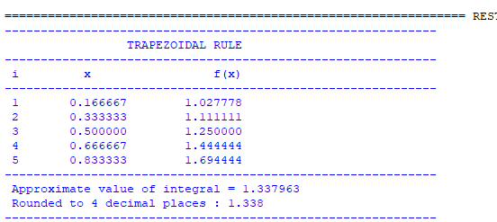

Conclusion: The above program has been executed successfully.

Q. Write a program in python to demonstrate Simpson’s 1/3rd rule.

Aim: To write a program in python to demonstrate Simpsons’s 1/3rd rule.

Program:
def f(x):
return x**2 + 1
a = 0
b = 1
n = 6
h = (b - a) / n
sum1 = 0
sum2 = 0
print("------------------------------------------------------------")
print(" SIMPSON'S 1/3 RULE")
print("------------------------------------------------------------")
print(" i\t x\t\t f(x)")
print("------------------------------------------------------------")
for i in range(1, n):
x = a + i * h
fx = f(x)
print(f" {i:<2}\t {x:<10.6f}\t {fx:<10.6f}")
if i % 2 == 0:
sum2 += fx
else:
sum1 += fx
I = (h / 3) * (f(a) + f(b) + 4 * sum1 + 2 * sum2)
print("------------------------------------------------------------")
print(f" Approximate value of integral = {I:.6f}")
print(f" Rounded to 4 decimal places : {round(I,4)}")
print("------------------------------------------------------------")

Output :
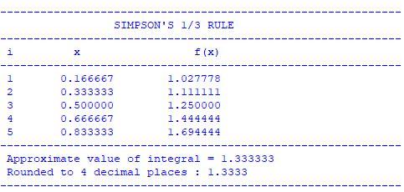

Conclusion: The above program has been executed successfully.

Q. Write a program in python to demonstrate Simpson’s 3/8th rule.

Aim: To write a program in python to demonstrate Simpsons’s 3/8th rule.

Program:
def f(x):
return x**2 + 1

a = 0
b = 1
n = 6
h = (b - a) / n
sum3 = 0
sum2 = 0
print("------------------------------------------------------------")
print(" SIMPSON'S 3/8 RULE")
print("------------------------------------------------------------")
print(" i\t x\t\t f(x)")
print("------------------------------------------------------------")
for i in range(1, n):
x = a + i * h
fx = f(x)
print(f" {i:<2}\t {x:<10.6f}\t {fx:<10.6f}")
if i % 3 == 0:
sum2 += fx
else:
sum3 += fx
I = (3 * h / 8) * (f(a) + f(b) + 3 * sum3 + 2 * sum2)
print("------------------------------------------------------------")
print(f" Approximate value of integral = {I:.6f}")
print(f" Rounded to 4 decimal places : {round(I,4)}")
print("------------------------------------------------------------")

Output :
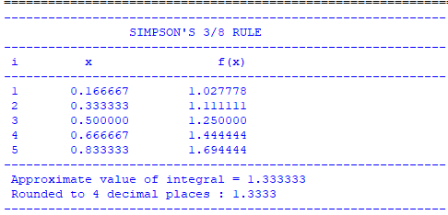

Conclusion: The above program has been executed successfully.

Q. Write a program in python to demonstrate Northwest corner method.

Aim: To write a program in python to demonstrate Northwest corner method.

Program:
print("------------------------------------------------------------")
print(" NORTHWEST CORNER METHOD")
print("------------------------------------------------------------")
supply = [50, 60, 25]
demand = [30, 40, 20, 45]
m = len(supply)
n = len(demand)
cost = [
[2, 3, 1, 4],
[3, 2, 5, 9],
[8, 4, 3, 7]
]
allocation = [[0 for _ in range(n)] for _ in range(m)]
print(f" Supply : {supply}")
print(f" Demand : {demand}\n")
print(" Cost Matrix (C[i][j]) :")
for row in cost:
print(" ", row)
i, j = 0, 0
while i < m and j < n:
x = min(supply[i], demand[j])
allocation[i][j] = x
supply[i] -= x
demand[j] -= x
if supply[i] == 0 and i < m - 1:
i += 1
elif demand[j] == 0 and j < n - 1:
j += 1
else:
i += 1
j += 1
print("\n------------------------------------------------------------")
print(" Allocation Matrix (X[i][j]) :")
for row in allocation:
print(" ", row)
total_cost = 0
for i in range(m):
for j in range(n):
total_cost += allocation[i][j] * cost[i][j]
print("------------------------------------------------------------")
print(f" Total Transportation Cost = {total_cost}")
print("------------------------------------------------------------")

Output :
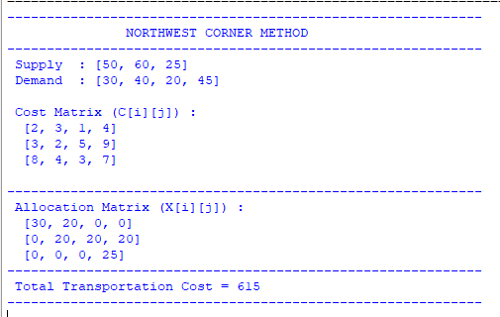

Conclusion: The above program has been executed successfully.

